RHEL7 Oracle 11.2.0.4

安装文档

|  |  |
| --- | --- |
|  |  |
|  |  |
|  |  |
|  |  |
|  |  |
|  |  |

# 文档控制

此文档仅供<xx公司>与利道公司技术部审阅，不得向与此无关的个人或机构传阅或复制。

## 修改记录

| **日期** | **作者** | **版本号** | **变更内容** |
| --- | --- | --- | --- |
|  |  |  |  |
| 2023.09.01 | 李曰福 | v1.0 | 创建 |
|  |  |  |  |
|  |  |  |  |

## 分发者

|  |  |
| --- | --- |
| **姓名** | **职位** |
|  |  |
|  |  |
|  |  |
|  |  |
|  |  |

## 审阅记录

|  |  |
| --- | --- |
| **姓名** | **职位** |
|  |  |
|  |  |
|  |  |
|  |  |

## 相关文档

Oracle技术参考

* Oracle Database (RDBMS) on Unix AIX,HP-UX,Linux,Mac OS X,Solaris,Tru64 Unix Operating Systems Installation and Configuration Requirements Quick Reference (8.0.5 to 11.2) (Doc ID 169706.1)
* How to Display and Change UNIX Process Resource Limits (Doc ID 188149.1)
* Missing pdksh-5.2.14 package during Oracle database 11.2.0.4 install on Oracle Linux 7 (Doc ID 1962046.1)
* Defining a "default RPMs" installation of the Oracle Linux (OL) OS (Doc ID 401167.1)
* Missing or Ignored package compat-libstdc++-33-3.2.3 causes Text Issues (Doc ID 2254198.1)
* Requirements for Installing Oracle 11.2.0.4 RDBMS on OL7 or RHEL7 64-bit (x86-64) (Doc ID 1962100.1)
* Upon startup of Linux database get ORA-27102: out of memory Linux-X86_64 Error: 28: No space left on device (Doc ID 301830.1)
* Startup Fails with ORA-27125 And Alert Log Shows "Error: ENOSPC while creating shared memory segment of size xxxxx bytes" (Doc ID 2325742.1

# 文档目录

文档控制 2

修改记录 2

分发者 2

审阅记录 2

相关文档 2

文档目录 3

本次服务总结 5

平台认证 5

Oracle数据库支持年限 5

安装步骤 6

OS资源配置规范 6

安装规范 7

Oracle 11g 用户/组管理规范 7

Oracle 11g 软件介质 7

Oracle 11g安装目录规范 7

数据库配置规范 7

数据库安装信息 8

安装准备 8

检查OS版本及内核版本 8

检查OS运行级别 8

主机名配置 8

检查OS时区 8

检查内存和SWAP大小 9

检查安装目录 9

关闭透明大页和NUMA 9

检查需求软件包 9

配置/etc/hosts 10

自动对时服务chrony或者ntp 11

Selinux 禁用 11

关闭防火墙 11

禁用avahi-daemon 11

创建组/用户 12

配置内核参数和网络参数 12

创建目录 13

配置环境变量 13

配置用户shell limits 13

配置用户登录权限 13

配置oracle自动启动服务 13

安装软件 14

编辑配置文件 11g-setup.ini 14

解压oracle安装包 14

修改静默安装rsp文件 15

建数据文件目录 15

执行安装 15

执行root.sh 15

打补丁 15

更新opatch 15

打补丁p14407401 15

打补丁p16811897 16

打补丁p31537677 16

DBCA建库 17

设置安装信息 17

静默配置侦听 17

建静默安装rsp文件 17

执行静默建库命令 17

执行postpatch和utlrp 18

检查组件和版本 18

11g 单实例数据库最佳实践 18

清理oracle安装 20

# 本次服务总结

|  |  |
| --- | --- |
| **总结** | * 本文档基于Oracle Online Document Install Guide。 * 在Red Hat Linux平台经过测试。 * 文档内容包括： * OS资源要求 * 数据库安装规范 * DBCA静默建库 * 补丁安装 * 最佳实践调整 |

# 平台认证

Oracle数据库支持年限

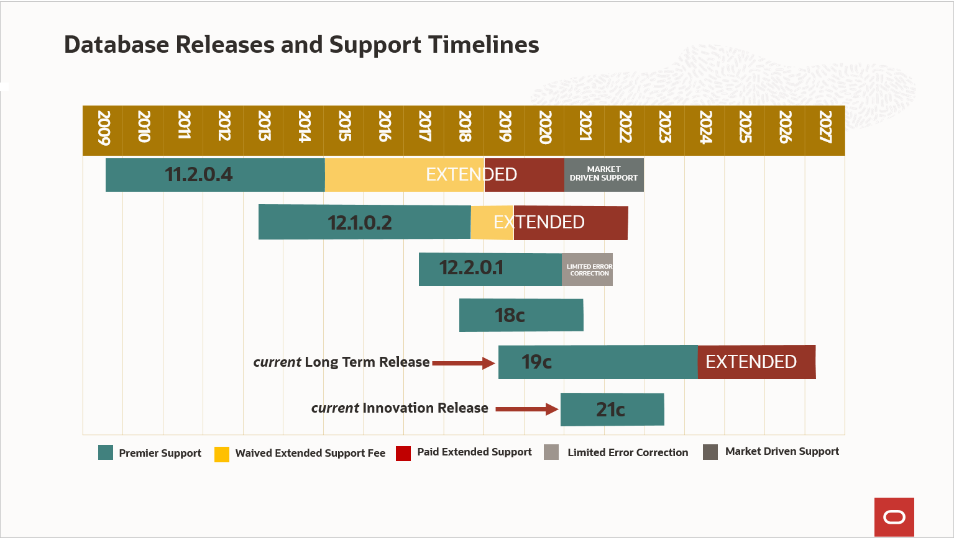

使用support.oracle.com的Certifications查看数据库的认证平台：

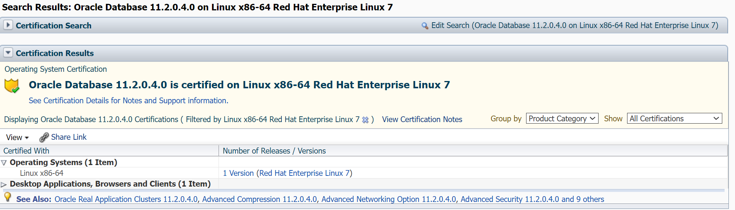

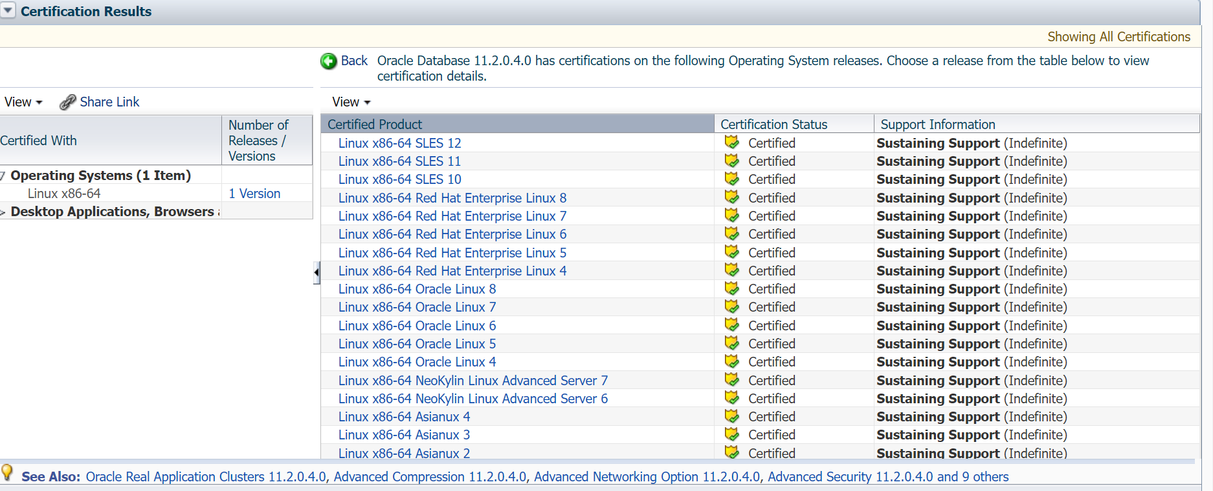

# 安装步骤

## OS资源配置规范

|  |  |
| --- | --- |
| 选项 | 描述 |
| RAM | minimum 1GB, recommended 2GB |
| /tmp | 至少1GB。 |
| SWAP | If RAM between 1 GB and 2 GB then 1.5 times the size fo RAM. If RAM between 2 GB to 16 GB then equal to the size of RAM. If RAM greater than 16 GB then 16 GB. |
| Run Level | 3/5 |
| RDBMS HOME | 建议大于等于100GB。 |
| OS安装软件包 | 参考Doc ID 401167.1, 见下图 |

Oracle Linux7缺省安装定义:

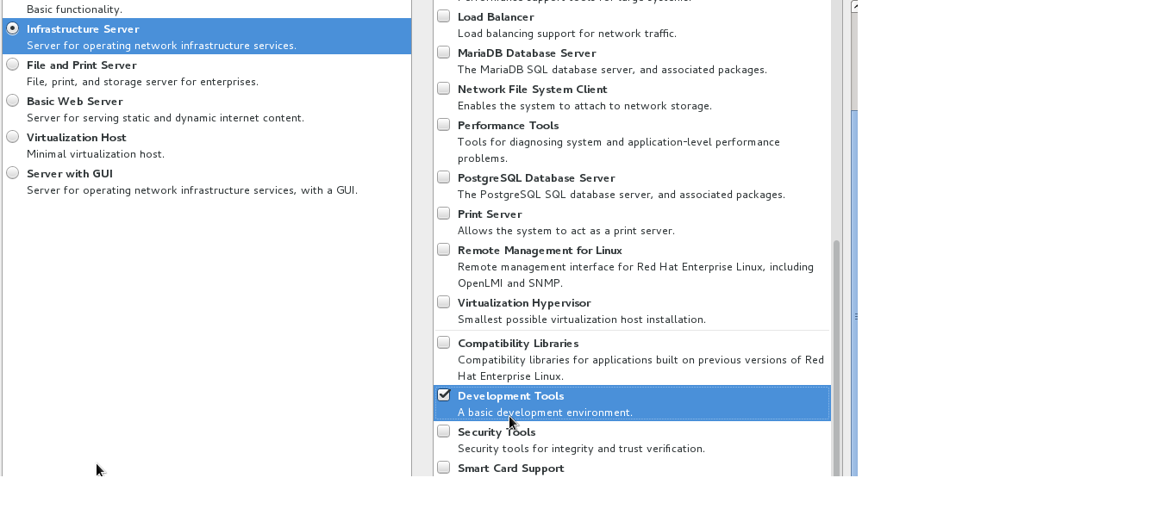

## 安装规范

### Oracle 11g 用户/组管理规范

组配置规范说明：

|  |  |  |
| --- | --- | --- |
| Name | REMARK | Necessity |
| oinstall | gid=1101,用于安装Oracle数据库软件 | *必建* |
| oper | gid=1102,用于对Oracle数据库做维护操作 | *必建* |
| dba | gid=1103,用于管理Oracle数据库 | *必建* |

用户配置规范说明：

|  |  |  |  |
| --- | --- | --- | --- |
| Name | UID | Prim Group | Auxiliary group |
| oracle | 1100 | oinstall(1101) | 1102(oper),1103(dba) |

### Oracle 11g 软件介质

安装前需准备以下安装介质，并放至目录 /stage中。

1. **Oracle Database安装介质：**

p13390677_112040_Linux-x86-64_1of7.zip

p13390677_112040_Linux-x86-64_2of7.zip

1. **Patch：**

p31537677_112040_Linux-x86-64.zip

p18841764_112040_Linux-x86-64.zip

p16811897_112040_Generic.zip

p14407401_112040_Generic.zip

1. **OPatch(OPATCH_VERSION:11.2.0.3.31)：**

p6880880_112000_Linux-x86-64.zip

安装包下载链接请求: 发email: yuefu.li@leaderit.com

另外需要把rhel-server-7.9-x86_64-dvd.iso (centos也可以)文件上传到/stage.

### Oracle 11g安装目录规范

安装目录规划原则：创建 /u01目录或者分区，用于Oracle数据库软件的安装。大小：150GB

Oracle Base目录：/u01/app/oracle

Oracle Home目录：/u01/app/oracle/product/11.2.0/dbhome_1

### 数据库配置规范

|  |  |
| --- | --- |
| 选项 | 描述 |
| 数据库版本 | 11.2.0.4 |
| 数据库监听端口 | 1521 |
| 数据库字符集 | GBK |
| 国家语言字符集 | AL16UTF16 |
| 数据库块大小 | 8K |

### 数据库安装信息

|  |  |
| --- | --- |
| 选项 | 描述 |
| 主机名 | aspdb |
| 主机IP | 192.168.56.22 |
| root密码 | oracle |
| oracle用户密码 | oracle |
| sysdba密码 | oracle |
| 数据库名 | aspdb |
| 数据存放目录 | /u02/oradata |
| ORACLE_HOME | /u01/app/oracle/product/11.2.0/dbhome_1 |
| ORACLE_BASE | /u01/app/oracle |

## 安装准备

### 检查OS版本及内核版本

检查OS版本和内核版本，确保满足11g的认证平台版本。

# cat /etc/redhat-release

# uname -a

### 检查OS运行级别

OS需要运行在3/5级别。

runlevel

N 3

### 主机名配置

主机名配置的工作由主机工程师完成，可以通过hostnamectl status命令查看主机名信息。注意：主机名以字母开头。

hostnamectl status

### 检查OS时区

在Linux 7上，可以使用命令"timedatectl"查看和修改OS时区。

注意：

* 根据行内标准，设置OS时区为东八区"Asia/Shanghai".

查看OS时区：

timedatectl status

### 检查内存和SWAP大小

可以通过/proc/meminfo或free命令查看OS当前的可用内存和Swap信息。

确保满足资源配置规范

egrep 'Mem|Swap' /proc/meminfo

### 检查安装目录

确保满足资源配置规范

df -h /u01 /tmp /dev/shm

### 关闭透明大页和NUMA

ref:ALERT: Disable Transparent HugePages on SLES11, RHEL6, RHEL7, OL6, OL7, and UEK2 and above (文档 ID 1557478.1)

**修改rc.local**

cat >> /etc/rc.local <<EOF

if test -f /sys/kernel/mm/redhat_transparent_hugepage/enabled; then

echo never > /sys/kernel/mm/redhat_transparent_hugepage/enabled

echo never > /sys/kernel/mm/redhat_transparent_hugepage/defrag

fi

if test -f /sys/kernel/mm/transparent_hugepage/enabled; then

echo never > /sys/kernel/mm/transparent_hugepage/enabled

echo never > /sys/kernel/mm/transparent_hugepage/defrag

fi

EOF

chmod +x /etc/rc.local

**修改grub**

mv /etc/default/grub /etc/default/grub.def

sed 's/\(.*\)quiet/\1quiet transparent_hugepage=never numa=off/' /etc/default/grub.def > /etc/default/grub

grub2-mkconfig -o /boot/grub2/grub.cfg

grub2-mkconfig -o /boot/efi/EFI/redhat/grub.cfg

grub2-mkconfig -o /boot/efi/EFI/centos/grub.cfg

重启服务器

**检查**

应该显示numa=off, [never](或者redhat_transparent_hugepage目录不存在)

dmesg |grep -I numa

cat /sys/kernel/mm/transparent_hugepage/enabled

cat /sys/kernel/mm/redhat_transparent_hugepage/enabled

### 检查需求软件包

ref：Oracle Document Install Guide for Linux Oracle Database (RDBMS) on Unix AIX,HP-UX,Linux,Mac OS X,Solaris,Tru64 Unix Operating Systems Installation and Configuration Requirements Quick Reference (8.0.5 to 11.2) (Doc ID 169706.1)

**配置yum源**

if [ ! -d /etc/yum.repos.d/bak ]; then

mkdir /etc/yum.repos.d/bak

fi

mv /etc/yum.repos.d/*.repo /etc/yum.repos.d/bak

cat > /etc/yum.repos.d/iso.repo <<EOF

[iso]

name=iso

baseurl=file:///mnt

enabled=1

gpgcheck=0

EOF

**挂载ISO光盘到/mnt**

mount -o loop /stage/rhel-server-7.9-x86_64-dvd.iso /mnt

**安装以下软件包**

cat > /stage/pkg.lst <<EOF

compat-libstdc++-33

binutils

compat-libcap1

gcc

gcc-c++

glibc

glibc-devel

ksh

libaio

libaio-devel

libgcc

libstdc++

libstdc++-devel

libXi

libXtst

make

sysstat

xdpyinfo

psmisc

expect

xorg-x11-xauth

EOF

yum install -y `awk '{print $1}' /stage/pkg.lst`

安装ompat-libstdc++(可选)

rpm -ivh /stage/compat-libstdc++-33*.rpm

注意：根据MOS文档Missing or Ignored package compat-libstdc++-33-3.2.3 causes Text Issues (Doc ID 2254198.1)的描述，在RHEL7中"compat-libstdc++-33" RPM包不在ISO镜像中，如果不使用Oracle Text组件，则没有影响，如果需要使用Oracle Text组件，那么需要安装该RPM包。

### 配置/etc/hosts

配置/etc/hosts，注意不要修改localhost那2行。

export HOST_NAME=aspdb

export HOST_IP=192.168.56.22

cat >> /etc/hosts <<EOF

${HOST_IP} ${HOST_NAME}

EOF

### 自动对时服务chrony或者ntp

* 如果使用chrony

增加一行server即可,比如设置服务器192.168.56.1

cat chrony.conf |grep server  
# Use public servers from the [pool.ntp.org](http://pool.ntp.org/) project.  
server  192.168.56.1 iburst

* 如果不使用chrony可以禁用

systemctl stop chronyd  
systemctl disable chronyd

mv /etc/chrony.conf /etc/chrony.conf.bak

* 如果使用NTP，则启用NTP的-x选项。

缺省不启用ntp.如果使用.

vi /etc/sysconfig/ntp 编辑并添加如下内容

#NTPD_OPTIONS="-g -u ntp:ntp"

NTPD_OPTIONS="-x -g -u ntp:ntp"

重启NTP 服务，检查slewing option 是否生效

service ntpd restart

ps -ef | grep ntp

检查输出结果是否含有"-x"

### Selinux 禁用

sed -i "s#SELINUX=enforcing#SELINUX=disabled#g" /etc/selinux/config  
setenforce 0

检查:

grep "SELINUX=" /etc/selinux/config

### 关闭防火墙

以root用户身份执行如下命令

检查防火墙状态

systemctl status firewalld

systemctl is-enabled firewalld

关闭/禁用防火墙

systemctl stop firewalld

systemctl disable firewalld

### 禁用avahi-daemon

systemctl stop avahi-dnsconfd

systemctl stop avahi-daemon

systemctl disable avahi-dnsconfd

systemctl disable avahi-daemon

### 创建组/用户

export ORACLE_PASSWORD=oracle

groupadd -g 1101 oinstall

groupadd -g 1102 oper

groupadd -g 1103 dba

useradd oracle -p $(echo "$ORACLE_PASSWORD"| openssl passwd -1 -stdin) -u 1101 -g 1101 -G 1101,1102,1103

### 配置内核参数和网络参数

ref:

|  |  |
| --- | --- |
|  | Oracle Database (RDBMS) on Unix AIX,HP-UX,Linux,Mac OS X,Solaris,Tru64 Unix Operating Systems Installation and Configuration Requirements Quick Reference (8.0.5 to 11.2) (Doc ID 169706.1) |

内核参数值配置需求：

|  |  |
| --- | --- |
| Parameter | Value |
| **semmsl** | 250 |
| **semmns** | 32000 |
| **semopm** | 100 |
| **semmni** | 128 |
| **shmall** | 物理内存字节数除以pagesize(一般是4096).比如64G,64*1024*1024*1024=4096 = 16777216.缺省的linux7的shmall为18446744073692774399, 远大于这个值,可以不改. |
| **shmmax** | 物理内存字节数除以2.比如64G,是64*1024*1024*1024 / 2 = 34359738368. 缺省的linux7的shmmax为18446744073692774399,远大于这个值,可以不改.查看当前值: cat /proc/sys/kernel/shmall |
| **shmmni** | 4096. (SHMMNI - kernel parameter controlling maximum number of shared memory segments in the system) |
| **panic_on_oops** | 1 |
| **file-max** | 6815744 |
| **aio-max-nr** | 1048576  Note: This value limits concurrent outstanding requests and should be set to avoid I/O subsystem failures. |
| **ip_local_port_range** | Minimum: 9000  Maximum: 65500 |
| **rmem_default** | 262144 |
| **rmem_max** | 4194304 |
| **wmem_default** | 262144 |
| **wmem_max** | 1048576 |

cat > /etc/sysctl.conf<<EOF

fs.aio-max-nr = 1048576

fs.file-max = 6815744

kernel.sem = 250 32000 100 128

kernel.shmmni = 4096

kernel.shmall = 18446744073692774399

kernel.shmmax = 18446744073692774399

net.ipv4.ip_local_port_range = 9000 65500

net.core.rmem_default = 262144

net.core.rmem_max = 4194304

net.core.wmem_default = 262144

net.core.wmem_max = 1048576

#vm.min_free_kbytes = 524288

#vm.nr_hugepages= xx

EOF

### 创建目录

mkdir -p /u01/app/oracle/product/11.2.0/dbhome_1

chown -R oracle:oinstall /u01

chmod -R 775 /u01

### 配置环境变量

[oracle]$ vi .bash_profile

umask 022

export ORACLE_BASE=/u01/app/oracle

export ORACLE_HOME=/u01/app/oracle/product/11.2.0/dbhome_1

export ORACLE_SID=aspdb

export NLS_LANG=AMERICAN_AMERICA.ZHS16GBK

export NLS_DATE_FORMAT="YYYY-MM-DD HH24:MI:SS"

export LD_LIBRARY_PATH=${ORACLE_HOME}/lib

export PATH=${ORACLE_HOME}/bin:${ORACLE_HOME}/OPatch:${PATH}

if [ -t 0 ]; then

stty intr ^C

fi

### 配置用户shell limits

cat > /etc/security/limits.d/99-oracle-limits.conf <<EOF

oracle soft nproc 2047

oracle hard nproc 16384

oracle soft nofile 1024

oracle hard nofile 65536

oracle soft stack 10240

oracle hard stack 32768

oracle soft memlock -1

oracle hard memlock -1

EOF

cat > /etc/profile.d/oracle.sh <<EOF  
#Setting the appropriate ulimits for oracle  
if [ \$USER = "oracle" ]; then  
 if [ \$SHELL = "/bin/ksh" ]; then  
 ulimit -u 16384  
 ulimit -n 65536  
 else  
 ulimit -u 16384 -n 65536  
 fi  
fi  
EOF

# source /etc/profile

$ ulimit -a

### 配置用户登录权限

echo "session required pam_limits.so" >> /etc/pam.d/login

### 配置oracle自动启动服务

cat > /lib/systemd/system/dbora.service <<EOF

[Unit]

Description=Oracle Database Start/Stop Service

After=syslog.target network.target local-fs.target remote-fs.target

[Service]

# systemd, by design does not honor PAM limits

# See: https://bugzilla.redhat.com/show_bug.cgi?id=754285

LimitNOFILE=65536

LimitNPROC=16384

LimitSTACK=32M

LimitMEMLOCK=infinity

LimitCORE=infinity

Type=simple

User=oracle

Group=oinstall

Restart=no

ExecStartPre=/bin/rm -f $DB_HOME/listener.log

ExecStartPre=/bin/rm -f $DB_HOME/startup.log

ExecStart=$DB_HOME/bin/dbstart $DB_HOME

RemainAfterExit=yes

ExecStop=/bin/rm -rf $DB_HOME/shutdown.log

ExecStop=$DB_HOME/bin/dbshut $DB_HOOME

TimeoutStopSec=5min

[Install]

WantedBy=multi-user.target

EOF

## 安装软件

如下都以root执行.不需要xwindow.

### 编辑配置文件 11g-setup.ini

根据数据库安装信息修改

cd /stage

cat > 11g-setup.ini<<EOF

export HOST_NAME=aspdb

export HOST_IP=192.168.56.22

#os密码

export ORACLE_PASSWORD=oracle

export ROOT_PASSWORD=oracle

#oracle 密码

export SYS_PASSWORD=oracle

export DB_NAME=aspdb

export ORA_INVENTORY=/u01/app/oraInventory

export DB_BASE=/u01/app/oracle

export DB_HOME=/u01/app/oracle/product/11.2.0/dbhome_1

export DATA_PATH=/u02/oradata

EOF

### 解压oracle安装包

unzip -oq /stage/p13390677_112040_Linux-x86-64_1*.zip > /tmp/unzip_db.log

unzip -oq /stage/p13390677_112040_Linux-x86-64_2*.zip >> /tmp/unzip_db.log

mkdir /stage/patch

chown -R oracle:oinstall /stage

### 修改静默安装rsp文件

source /stage/11g-setup.ini

/usr/bin/cp -f /stage/database/response/db_install.rsp /stage/db_install.rsp

sed -i '/^#.*$/d' /stage/db_install.rsp

sed -i '/^$/d' /stage/db_install.rsp

sed -i "s#\(oracle.install.option=\)#\1INSTALL_DB_SWONLY#g" /stage/db_install.rsp

sed -i "s/\(ORACLE_HOSTNAME=\)/\1${HOST_NAME}/g" /stage/db_install.rsp

sed -i "s/\(UNIX_GROUP_NAME=\)/\1oinstall/g" /stage/db_install.rsp

sed -i "s#\(INVENTORY_LOCATION=\)#\1${ORA_INVENTORY}#g" /stage/db_install.rsp

sed -i "s#\(ORACLE_HOME=\)#\1${DB_HOME}#g" /stage/db_install.rsp

sed -i "s#\(ORACLE_BASE=\)#\1${DB_BASE}#g" /stage/db_install.rsp

sed -i "s/\(oracle.install.db.InstallEdition=\)/\1EE/g" /stage/db_install.rsp

sed -i "s/\(oracle.install.db.DBA_GROUP=\)/\1dba/g" /stage/db_install.rsp

sed -i "s/\(oracle.install.db.OPER_GROUP=\)/\1oper/g" /stage/db_install.rsp

sed -i "s/\(oracle.install.db.config.starterdb.type=\)/\1GENERAL_PURPOSE/g" /stage/db_install.rsp

sed -i "s#\(DECLINE_SECURITY_UPDATES=\)#\1TRUE#g" /stage/db_install.rsp

cat > /stage/db_install.sh <<EOF

cd /stage/database

./runInstaller -ignorePrereq -waitforcompletion -silent -showprogress -responsefile /stage/db_install.rsp

EOF

chmod 755 /stage/db_install.sh

### 建数据文件目录

if [ $DATA_PATH ] ; then

mkdir -p $DATA_PATH

fi

chown -R oracle:oinstall $DATA_PATH

### 执行安装

su - oracle -c "sh /stage/db_install.sh"

### 执行root.sh

sh ${ORA_INVENTORY}/orainstRoot.sh

sh ${DB_HOME}/root.sh

## 打补丁

如下以oracle用户执行

su - oracle

source /home/oracle/.bash_profile

### 更新opatch

cd $ORACLE_HOME

mv OPatch `date +'%Y-%m-%d-%H-%M-%S'`.OPatch

unzip /stage/p6880880_112000_Linux-x86-64.zip

### 打补丁p14407401

rm -rf /stage/patch/144

mkdir -p /stage/patch/144

chown oracle:oinstall /stage/patch/144

cd /stage/patch/144;unzip /stage/p14407401_112040_Generic.zip

#patch p144

cat > /tmp/p144.expect <<EOF

#!/usr/bin/expect -f

spawn $ORACLE_HOME/OPatch/opatch apply

set timeout 10

expect "Do you want to proceed? \[y|n\]"

send "y\r"

set timeout 60

expect eof

EOF

执行expect文件

chmod +x /tmp/p144.expect

cd /stage/patch/144/14407401

/tmp/p144.expect

### 打补丁p16811897

rm -rf /stage/patch/168

mkdir -p /stage/patch/168

chown oracle:oinstall /stage/patch/168

cd /stage/patch/168;unzip /stage/p16811897_112040_Generic.zip

cat > /tmp/p168.expect <<EOF

#!/usr/bin/expect -f

spawn $ORACLE_HOME/OPatch/opatch apply

set timeout 10

expect "Do you want to proceed? \[y|n\]"

send "y\r"

set timeout 60

expect eof

EOF

chmod +x /tmp/p168.expect

cd /stage/patch/168/16811897

/tmp/p168.expect

### 打补丁p31537677

cd /stage/patch

unzip /stage/p31537677_112040_*.zip

cat > /tmp/p315.expect <<EOF

#!/usr/bin/expect -f

spawn $ORACLE_HOME/OPatch/opatch apply

set timeout 10

expect "Do you want to proceed? \[y|n\]"

send "y\r"

set timeout 10

expect "Is the local system ready for patching? \[y|n\]"

send "y\r"

set timeout 300

expect eof

EOF

#执行expect文件

chmod +x /tmp/p315.expect

cd /stage/patch/31537677

/tmp/p315.expect

## DBCA建库

以oracle用户登录.使用oracle用户执行dbca命令创建数据库。

### 设置安装信息

source /stage/11g-setup.ini

### 静默配置侦听

#create listener

$ORACLE_HOME/bin/netca -silent -responsefile $ORACLE_HOME/assistants/netca/netca.rsp

### 建静默安装rsp文件

cat > /stage/db_create.rsp<<EOF

[GENERAL]

RESPONSEFILE_VERSION = "11.2.0"

OPERATION_TYPE = "createDatabase"

[CREATEDATABASE]

GDBNAME = "${DB_NAME}"

SID = "${DB_NAME}"

TEMPLATENAME = "lidao_11g.dbt"

CHARACTERSET = "ZHS16GBK"

NATIONALCHARACTERSET = "AL16UTF16"

MEMORYPERCENTAGE = "75"

EMCONFIGURATION = "NONE"

SYSPASSWORD = "${SYS_PASSWORD}"

SYSTEMPASSWORD = "${SYS_PASSWORD}"

DBSNMPPASSWORD = "${SYS_PASSWORD}"

SYSMANPASSWORD = "${SYS_PASSWORD}"

EOF

cp /stage/lidao_11g.dbt $ORACLE_HOME/assistants/dbca/templates/lidao_11g.dbt

if [ $DATA_PATH ] ; then

#用户自定义了数据存放目录

if [ -d $DATA_PATH ]; then

echo -e "DATA_PATH is $DATA_PATH\n"

sed -i "s#DATA_PATH#${DATA_PATH}#g" $ORACLE_HOME/assistants/dbca/templates/lidao_11g.dbt

else

echo "Please check $DATA_PATH, make sure it exists and owner is oracle:oinstall"

exit 1;

fi

fi

### 执行静默建库命令

$ORACLE_HOME/bin/dbca -silent -force -responseFile /stage/db_create.rsp

## 执行postpatch和utlrp

sqlplus / as sysdba <<EOF

@?/sqlpatch/14407401/postinstall.sql

exit

EOF

sqlplus / as sysdba <<EOF

@?/sqlpatch/16811897/postinstall.sql

exit

EOF

#根据 p31537677的readme,打补丁后建库,不需要执行p31537677的postpatch.

# 检查组件和版本

sqlplus / as sysdba <<EOF

set linesize 120;  
col comp_id format a10;  
col comp_name format a35;  
col version format a15;  
col status format a8;  
col modified format a30;  
select comp_id,replace(comp_name,' ','.') comp_name,version,status,replace(replace(modified,' ',':'),'-','/') modified from dba_registry;

set linesize 150

col action for a10

col action_time for a20

col namespace for a15  
col comments for a30  
col bundle_series for a10  
select * from dba_registry_history;

EOF

cd $ORACLE_HOME/OPatch

./opatch lspatches

# 11g 单实例数据库最佳实践

--检查aio

COL NAME FORMAT A50

SELECT NAME,ASYNCH_IO FROM V$DATAFILE F,V$IOSTAT_FILE I

WHERE F.FILE#=I.FILE_NO

AND FILETYPE_NAME='Data File';

--启用aio

alter system set filesystemio_options=setall scope=spfile;

--禁用自动任务

alter profile default limit PASSWORD_LIFE_TIME unlimited;

begin

dbms_auto_task_admin.disable(client_name=>'sql tuning advisor',operation=>NULL,window_name=>NULL);

end;

/

begin

dbms_auto_task_admin.disable(client_name=>'auto space advisor',operation=>NULL,window_name=>NULL);

end;

/

begin

dbms_auto_task_admin.disable(client_name=>'auto optimizer stats collection',operation=>NULL,window_name=>NULL);

end;

/

select client_name, status from dba_autotask_client;

--其它

alter system set deferred_segment_creation=false scope=spfile sid='*';

alter system set audit_trail=none scope=spfile sid='*';

alter system set aq_tm_processes=10 scope=spfile sid='*';

alter system set open_cursors=3000 scope=spfile sid='*';

alter system set fast_start_mttr_target=900 scope=spfile sid='*';

alter system set db_flashback_retention_target=10800 scope=spfile sid='*';

alter system set undo_retention=10800 scope=spfile sid='*';

alter system set optimizer_capture_sql_plan_baselines=false scope=spfile sid='*';

alter profile default limit PASSWORD_LIFE_TIME unlimited;

--重启

shutdown immediate;

startup

--检查aio

COL NAME FORMAT A50

SELECT NAME,ASYNCH_IO FROM V$DATAFILE F,V$IOSTAT_FILE I

WHERE F.FILE#=I.FILE_NO

AND FILETYPE_NAME='Data File';

# 清理oracle安装

#如果需要清理oracle环境重新安装

1. 删除安装目录/u01,/u02/oradata,/tmp下的oracle的文件

rm -rf /u01 /u02/oradata

find /tmp -user oracle -delete

2. 以root执行

rm -f /etc/oratab /etc/oraInst.loc

3. 删除oracle用户和组

userdel -fr oracle

groupdel oinstall

groupdel oper

groupdel dba